**Chemistry 12 - Organic** **Families**

**Chapter 6.1 Organic families**

1. Can organic compounds be made from inorganic compounds? Give an example.

________________________________________________________________________________________________________________________________________________________________________________

1. What percentage of chemical compounds are organic compounds? _______
2. Explain the difference between synthetic and natural organic compounds.

**__________________________________________________________________________________**

**__________________________________________________________________________________**

1. Explain why the **type of atoms present** in a molecule as wells their **overall shape** is so significant to the chemistry of organic substances.

**__________________________________________________________________________________**

**__________________________________________________________________________________**

1. What determines the 'family' that a particular organic substance belongs to? Name three families.

**__________________________________________________________________________________**

**__________________________________________________________________________________**

1. Why is it helpful to know what family a molecule belongs to?

**__________________________________________________________________________________**

**__________________________________________________________________________________**

1. Why is the ball and stick model preferred over the space filled model? Identify each of the types of models from the pictures below.

**__________________________________________________________________________________**

**__________________________________________________________________________________**

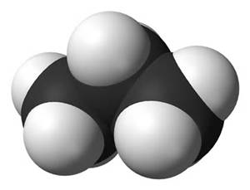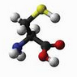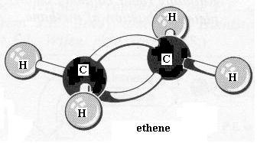

____________ ______________ ___________________

1. Why is the space filled model actually more realistic even though organic chemists prefer ball and stick?

**__________________________________________________________________________________**

**__________________________________________________________________________________**

1. Fill in the table below.

|  |  |  |
| --- | --- | --- |
| Bonds around C atom | Geometric Shape | Geometric shape and angles between bonds |
| Four single bonds |  |  |
| One double bond and two singles |  |  |
| Two double bonds |  |  |
| One triple bond and one single |  |  |

**Chapter 6.2 Hydrocarbons and 6.3 Branched Chain Hydrocarbons (Two Chapters Combined)**

1. What is a hydrocarbon? Give some examples.

______________________________________________________________________________

______________________________________________________________________________

1. Practicing alkene nomenclature:

i. Which of the molecules below is 3,4-dimethylpent-2-ene?   
 A. B. C.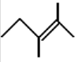 D.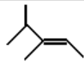

ii. Which molecule is 3-ethylpent-2-ene?

A.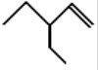 B. 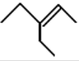 C. D.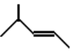

iii. Which molecule is 5-methylhex-1-ene?

A. B.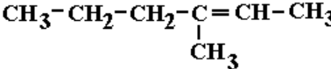 C.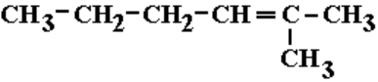 D.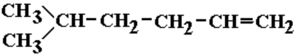

iv. Which molecule is **3,3-dimethylpent-1-ene**?

A.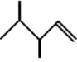 B.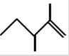 C. D.

v. Which molecule is **3,4-dimethylpent-1-ene?**

A.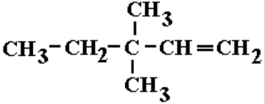 B.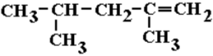 C.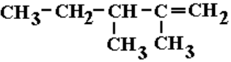 D.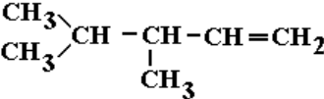

vi. Which molecule is **2-methylpent-2-ene**?

A. B.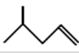 C. D.

vii. Which molecule is **2-methylbut-2-ene**?

A. 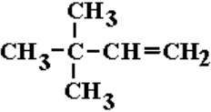 B.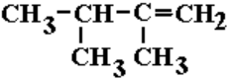 C.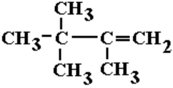 D.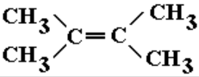

1. Name the following molecules.

a. ____________________________

b.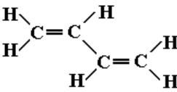______________________________

1. Fill in the table below.

Use the word bank: (some words are used more than once)

Saturated, Hydrocarbons, Unsaturated, Alkanes, Cycloalanes, Aliphatics, Cycloalkenes, Alkynes, Chain, Alkanes, Cycloalkynes, Cyclic, Aromatics

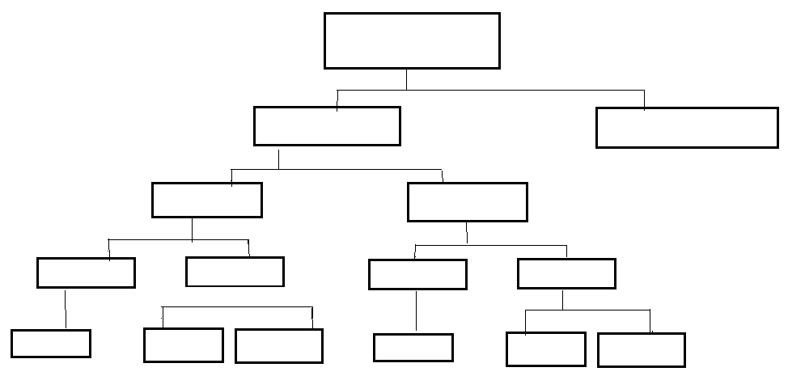

1. Naming of alkane side groups

|  |  |  |  |  |  |  |  |  |  |  |
| --- | --- | --- | --- | --- | --- | --- | --- | --- | --- | --- |
| No. of C | 1 | 2 | 3 | 4 | 5 | 6 | 7 | 8 | 9 | 10 |
| Stem name |  |  |  |  |  |  |  |  |  |  |

Other common side groups are:

|  |  |  |  |  |  |
| --- | --- | --- | --- | --- | --- |
| Side group | F | Cl | Br | I | NO2 |
| Name of side group |  |  |  |  |  |

1. Naming alkanes, alkenes and alkynes

a) Look for a functional group (i.e. double bond or triple bond).

b) Look for the longest chain attached to this functional group and start numbering such that the functional group has the lowest number in this longest chain.

c) Determine the location (carbon number) of all the side groups and start the naming of the compound with the side group that is closest to the start of the alphabet. Put comas between numbers and a dash between words and numbers. Notice it is the name of the side group not the di, tri etc. that determines the order in a name.

i.e. 1,2,2-tribromo-3,3-dimethyl hexane

1. Classify the compound then name it.

|  |  |  |  |  |
| --- | --- | --- | --- | --- |
| Compound | Aromatic/Aliphatic | Chain/Cyclic | Saturated/Unsat | Name |
|  |  |  |  |  |
|  |  |  |  |  |
|  |  |  |  |  |
|  |  |  |  |  |
|  |  |  |  |  |
|  |  |  |  |  |
|  |  |  |  |  |

Practice naming aliphatics and aromatics at:http://hrsbstaff.ednet.ns.ca/benoitn/chem11/units/4.%20Organic/unit_organic.htm

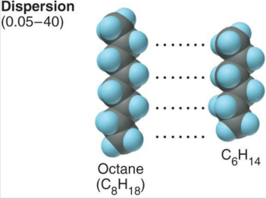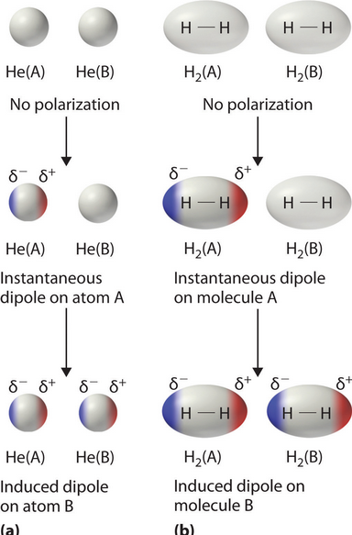**Structure and Bonding of Hydrocarbons**

1. What are dispersion forces? How does this type of force relate to hydrocarbons.

_______________________________________________________

_______________________________________________________

_______________________________________________________

_______________________________________________________

_______________________________________________________

_______________________________________________________

_______________________________________________________

1. Are dispersion forces, intramolecular or intermolecular forces.

______________________________________________________

______________________________________________________

1. Explain what a non-polar molecule is and why dispersion forces are important to non-polar molecules.

_______________________________________________________________________________________

_______________________________________________________________________________________

_______________________________________________________________________________________

1. 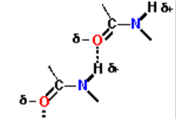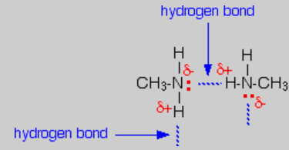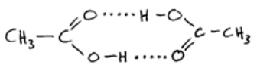What types of atoms inside organic compounds can cause hydrogen bonding forces to occur.

_________________________________________

1. Are hydrogen bonding forces stronger or weaker than dispersion forces?

_____________________________________________________________________

1. Explain how the additional effect of hydrogen bonding could affect properties such as melting and boiling point, and solubility in water.

__________________________________________________________________________________

__________________________________________________________________________________

__________________________________________________________________________________

__________________________________________________________________________________

__________________________________________________________________________________

__________________________________________________________________________________

1. 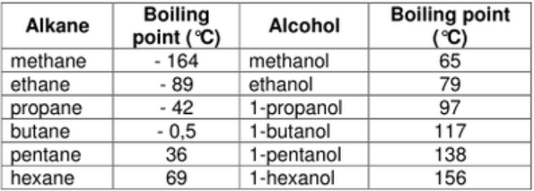Explain how size of a hydrocarbon could affect melting and boiling point as well as solubility if it is a substance that can undergo hydrogen bonding.

_____________________________________________

_____________________________________________

_____________________________________________

__________________________________________________________________________________

__________________________________________________________________________________

__________________________________________________________________________________

1. Which compound in each pair would be more soluble in water? Explain your answer.
2. Ethanol or ethane?

__________________________________________________________________________________

__________________________________________________________________________________

__________________________________________________________________________________

1. Ethanoic acid or ethanol?

__________________________________________________________________________________

__________________________________________________________________________________

__________________________________________________________________________________

1. Ethane or Hexane?

__________________________________________________________________________________

__________________________________________________________________________________

__________________________________________________________________________________

1. Which organic compound would have a higher density and which will have a lower boiling point? Explain your answer.
2. 2,2 dimethyl butane or butane?

__________________________________________________________________________________

__________________________________________________________________________________

__________________________________________________________________________________

__________________________________________________________________________________

__________________________________________________________________________________

1. Oxalic acid or pentane?

__________________________________________________________________________________

__________________________________________________________________________________

__________________________________________________________________________________

__________________________________________________________________________________

__________________________________________________________________________________

**Isomers of Alkenes**

1. Describe the difference between a structural isomer and a geometric isomer.

__________________________________________________________________________________

__________________________________________________________________________________

__________________________________________________________________________________

1. Draw four structural isomers of C5H12 and name these isomers
2. Draw two geometric isomers of C3H6
3. Draw both structural and geometric isomers of C4H8
4. State the difference between cis and trans.

_________________________________________________________________________________

_________________________________________________________________________________

1. Look at the data below for cis and trans but-2-ene and identify which geometric isomer is more tightly packed and has stronger dispersion forces and why dispersion forces might be higher.

|  |  |  |  |
| --- | --- | --- | --- |
| Compound | Melting pt. (oC) | Boiling pt. (oC) | Density (g/mL) |
| Cis-but-2-ene | -139 | 4 | 0.615 |
| Trans-but-2-ene | -105.6 | 1 | 0.598 |

_________________________________________________________________________________

_________________________________________________________________________________

_________________________________________________________________________________

_________________________________________________________________________________

1. Comparing and contrasting the properties of Alkanes, Alkenes and Alkynes

|  |  |  |  |
| --- | --- | --- | --- |
| Property | Alkane | Alkene | Alkyne |
| Electrical conductivity |  |  |  |
| Melting and Boiling pt. | ______________________  ______________________  ______________________  ______________________  ______________________ | ______________________  ______________________  ______________________  ______________________  ______________________ | ______________________  ______________________  ______________________  ______________________  ______________________ |
| Solubility | _______________________  _______________________ | _______________________  _______________________ | _______________________  _______________________ |
| Combustion reaction |  |  |  |
| Substitution reaction | ______________________  ______________________  ______________________  ______________________  ______________________ |  |  |
| Addition reactions |  | ______________________  ______________________  ______________________  ______________________  ______________________ | ______________________  ______________________  ______________________  ______________________  ______________________ |

**Chapter 6.4 Aromatic Hydrocarbons**

1. Describe some of the unique features of the benzene ring found in all aromatics.

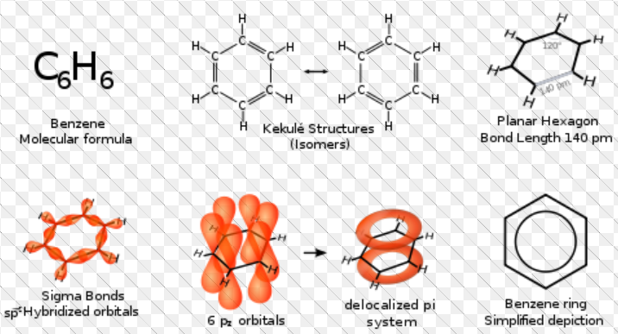

_______________________

_______________________

_______________________

_______________________

_______________________

_______________________

_______________________

_______________________

_______________________

__________________________________________________________________________________

__________________________________________________________________________________

1. Describe how the unique features of benzene affect the reactions aromatic substances undergo.

__________________________________________________________________________________

__________________________________________________________________________________

__________________________________________________________________________________

**Chapter 6.5 Functional Groups:**

1. It is important to be able to identify the following functional groups. Remember the functional group determines what you will consider to be the longest chain and will affect the ending of the substances name.

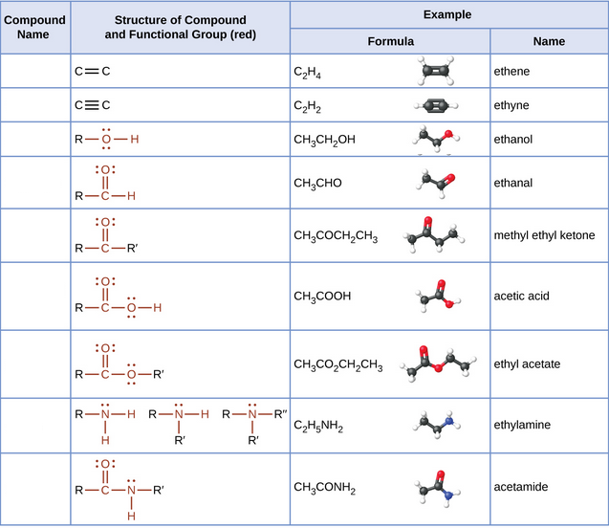

1. Fill in the table below.

|  |  |  |
| --- | --- | --- |
| Substances configuration | Priority Functional Group | Name |
|  |  |  |
|  |  |  |
|  |  |  |
|  |  |  |
|  |  |  |
|  |  |  |
|  |  |  |
|  |  |  |
|  |  |  |
|  |  |  |
|  |  |  |
|  |  |  |
|  |  |  |

1. Describe the difference between a primary, secondary and tertiary alcohol.

______________________________________________________________________________________

______________________________________________________________________________________

______________________________________________________________________________________

1. Identify whether the following alcohols are primary, secondary or tertiary alcohols.
2. ____________________________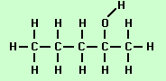

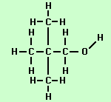

1. ____________________________

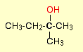

1. ___________________________



1. __________________________

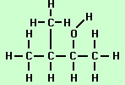

1. ____________________________



1. ________________________________
2. ________________________________

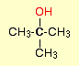

1. ________________________________
2. Compare and contrast the melting point, boiling point and solubility in water of the following compounds.

|  |  |  |
| --- | --- | --- |
| **Organic Compound** | **Melting Point (M.P.) and Boiling Point (B.P.)** | **Solubility in Water** |
| Butane |  |  |
| 1-Butanol or But-1-ol |  |  |
| 2-Butanol or But-2-ol |  |  |
| But-1,4-diol |  |  |
| 2-Methyl-2-propanol |  |  |
| **Organic Compound** | **Melting Point (M.P.) and Boiling Point (B.P.)** | **Solubility in Water** |
| Butanal |  |  |
| 2-Butanone  or  But-2-one |  |  |
| Butanoic acid |  |  |
| Ethylethanoate |  |  |
| 1-butanamine |  |  |
| **Organic Compound** | **Melting Point (M.P.) and Boiling Point (B.P.)** | **Solubility in Water** |
| Ethylethanamide |  |  |

1. a) Rank the following organic compounds in the order of their decreasing reactivity with sodium.

Butane, 1-Butanol, 2-Butanol, But-1,4-diol (1,4-Butanol), 2-methyl-2-propanol

_____________>_______________>_______________>______________>_______________

1. Rank the following organic compounds in the order of their decreasing reactivity with an oxidizing agent such as acidified dichromate ions.

Propane, 1-Propanol (or Prop-1-ol), 2-Propanol (or Prop-2-ol or Isopropanol (CH3)2CHOH)

_________________>____________________>__________________>__________________

1. Review the rules for naming substances using p. 92 of the WACE Study Guide.

Note: The main thing to add to what the students learned last year is the order of priority for naming substances. For example if a substance has a carboxyl group than the longest chain attached to the carboxyl group determines that end part of the substances name. The priority is:

1. Carboxylic acid 5. Alchols

2. _________________ 6. Amines

3. Aldehydes 7. Alkenes and Alkynes

4. Ketones 8. Alkyl groups and halides